**Classification:**

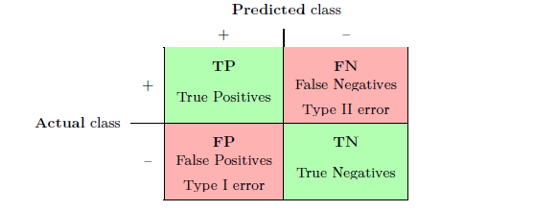

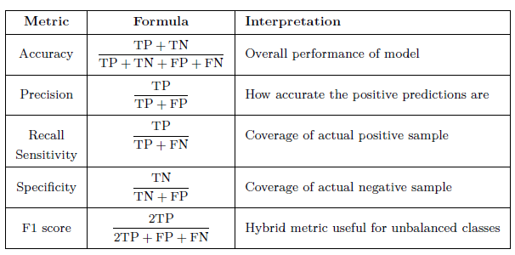

**Random Forest Classification – Evaluation Summary**

#### ****What does the confusion matrix show for the Random Forest model?****

* **True Negatives (TN)**: 78
* **False Positives (FP)**: 7
* **False Negatives (FN)**: 6
* **True Positives (TP)**: 43

**Classification Report - RF**

| **Class** | **Precision** | **Recall** | **F1-Score** | **Support** |
| --- | --- | --- | --- | --- |
| 0 | 0.93 | 0.92 | 0.92 | 85 |
| 1 | 0.86 | 0.88 | 0.87 | 49 |
| **Accuracy** | - | - | **0.90** | 134 |
| **Macro Avg** | 0.89 | 0.90 | 0.90 | 134 |
| **Weighted Avg** | 0.90 | 0.90 | 0.90 | 134 |

**Random Forest – Technical Q&A Based on Confusion Matrix**

**1. What is a Confusion Matrix in classification?**

**Answer**: It's a 2x2 table used to evaluate a classification model’s performance. It shows True/False Positives and Negatives.

**2. How many correct predictions were made by the Random Forest model?**

**Answer**: TN + TP = 78 + 43 = 121, correct predictions out of 134.

**3a. What is Precision for class 1? Or What is the percentage of the classification to sum of the correctly classified and wrongly classified in the test set?**

**Answer**: Precision = TP / (TP + FP) = 43 / (43 + 7) = **0.86**

**3b. What is Precision for class 0? Or What is the percentage of the classification to sum of the correctly classified and wrongly classified in the test set?**

**Answer**: Precision = TP / (TP + FP) = 78 / (78 + 6) = **0.93**

**4. What does Recall mean, and what is the value for class 1?**

**Or What is the percentage of correct classification of True Positives to the total input purchases of test set?**

**Answer**: Recall = TP / (TP + FN) = 43 / (43 + 6) = **0.88**  
Recall measures how well the model identifies actual positives.

**5. What is F1-Score and its use?**

**Answer**: F1-score = 2 × (Precision × Recall) / (Precision + Recall). It's the harmonic mean of precision and recall, especially useful for imbalanced datasets.

**6. What is the accuracy of this Random Forest model?**

**Answer**: TP+TN/TN+TP+FN+FP=>78+43/78+7+6+43=>121/134

= 0.90 or **90%** accuracy.

**7. Is the model better at identifying class 0 or class 1?**

**Answer**: Slightly better at identifying class 0 due to higher precision (0.93 vs. 0.86).

**8. What does a False Positive mean in this context?**

**Answer**: The model incorrectly predicted a user **would purchase** when they actually didn’t (7 such cases).

**1. What is the accuracy of the Random Forest model?**

* **Answer:** The accuracy of the Random Forest model is **90%**, as shown in the classification report. This means the model correctly predicted 90% of the test instances.
* TP+TN/TN+TP+FN+FP

**2. What does the precision of 0.93 for class 0 indicate?**

* **Answer:** A precision of 0.93 for class 0 means that when the model predicts a user did not purchase (class 0), it is correct **93%** of the time. In other words, out of all predicted non-purchases, 93% were actual non-purchases.

**3. What does the recall of 0.92 for class 0 represent?**

* **Answer:** A recall of 0.92 for class 0 means the model correctly identified **92%** of the actual non-purchases in the test set. It missed 8% of the true non-purchases.

**4. How is the F1-score calculated, and what does it represent?**

* **Answer:** The F1-score is the harmonic mean of precision and recall. For class 0, it is calculated as:  
  F1=2×Precision×RecallPrecision+Recall=2×0.93×0.920.93+0.92=0.92*F*1=2×*Precision*+*RecallPrecision*×*Recall*​=2×0.93+0.920.93×0.92​=0.92.  
  It represents a balance between precision and recall, with 0.92 indicating strong performance for class 0.

**5. What does the confusion matrix show for the Random Forest model?**

* **Answer:** The confusion matrix is:
  + **True Negatives (TN):** 78 (correct non-purchases).
  + **False Positives (FP):** 7 (incorrectly predicted as purchases).
  + **False Negatives (FN):** 6 (incorrectly predicted as non-purchases).
  + **True Positives (TP):** 43 (correct purchases).

**6. How would you interpret the macro avg and weighted avg in the report?**

* **Answer:**
  + **Macro Avg:** Averages the metrics (precision/recall/F1) across both classes without considering class imbalance. Here, it is **0.89** for precision and **0.90** for recall.
  + **Weighted Avg:** Averages metrics by weighting them based on class support (number of instances). Here, it is **0.90** for precision and recall, reflecting the model's performance accounting for class distribution or PROPORTION RATE.

**Decision Tree Classification – Evaluation Summary**

* **True Negatives (TN)**: 78
* **False Positives (FP)**: 7
* **False Negatives (FN)**: 6
* **True Positives (TP)**: 43

**Classification Report - DT**

| **Class** | **Precision** | **Recall** | **F1-Score** | **Support** |
| --- | --- | --- | --- | --- |
| 0 | 0.90 | 0.89 | 0.90 | 85 |
| 1 | 0.82 | 0.84 | 0.83 | 49 |
| **Accuracy** | - | - | **0.87** | 134 |
| **Macro Avg** | 0.86 | 0.87 | 0.86 | 134 |
| **Weighted Avg** | 0.87 | 0.87 | 0.87 | 134 |

**Decision Tree – Technical Q&A Based on Confusion Matrix**

**1. How many correct predictions were made by the Decision Tree model?**

**Answer**: TN+TP=78+43=121,

TN + TP = 78 + 43 = 121

correct predictions out of 134.

**2a. What is Precision for class 1? Or What is the percentage of the classification to sum of the correctly classified and wrongly classified in the test set?**

**Answer**: Precision = TP / (TP + FP) = 43 / (43 + 7) = **0.82**

**2b. What is Precision for class 0? Or What is the percentage of the classification to sum of the correctly classified and wrongly classified in the test set?**

**Answer**: Precision = TN / (TN + FN) = 78 / (78 + 7) = **0.90**

**3a. What does Recall mean, and what is the value for class 1?**

**Answer**: Recall = TP / (TP + FN) = 43 / (43 + 6) = **0.84**  
Recall measures how well the model identifies actual positives.

**4. What is F1-Score and its use?**

**Answer**: F1-score = 2 × (Precision × Recall) / (Precision + Recall). It's the harmonic mean of precision and recall, especially useful to find out **overall performance** each imbalanced datasets

**5. What is the accuracy of this DT model?**

**Answer**: 0.87

**6. Is the model better at identifying class 0 or class 1?**

**Answer**: Slightly better at identifying class 0 due to higher precision (0.90 vs. 0.82).

**7. What does a False Positive mean in this context?**

**Answer**: The model incorrectly predicted a user **would purchase** when they actually didn’t (7 such cases).

**8. What is the accuracy of the Decision Tree model?**

* **Answer:** The accuracy of the Decision Tree model is **87%**, as shown in the classification report. This is slightly lower than the Random Forest model.

**9. What does the precision of 0.90 for class 0 indicate?**

* **Answer:** A precision of 0.90 for class 0 means that when the model predicts a user did not purchase (class 0), it is correct **90%** of the time. This is slightly lower than the Random Forest's precision for the same class.